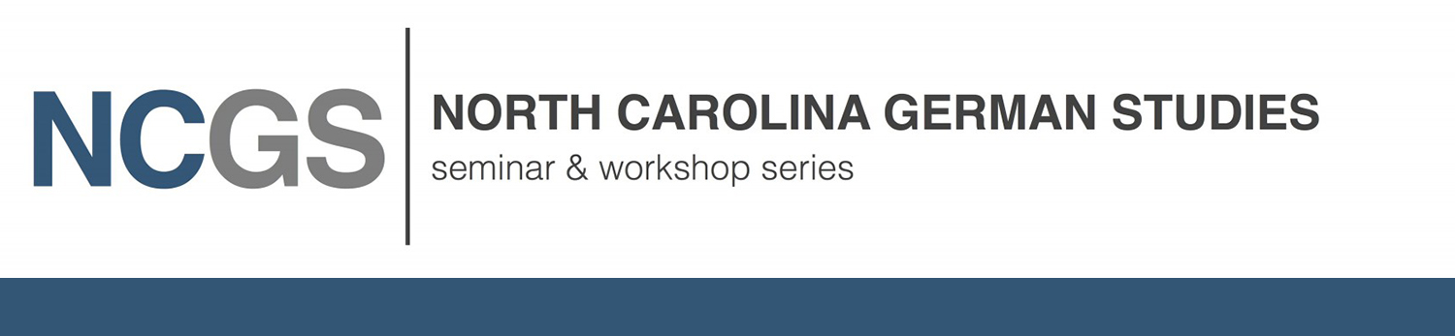

Co-Conveners: Duke University and University of North Carolina Chapel Hill, Departments of History
Friday, 16 February 2024
2:00 – 4:00 pm Zoom Seminar

KAREN HAGEMANN
James G. Kenan Distinguished Professor of History
UNC at Chapel Hill, Department of History

CONTESTED PROGRESS:
Women and Women’s Studies at East and West German Universities –
The Example of History

How to explain the causes of the persistent discrimination faced by women at universities in the two German states until 1989? Based on the example of the historical profession, a discipline of central importance in the humanities for the formulation of historical “master narratives” to interpret the past, the presentation explores both women’s changing position in the historical profession in East and West Germany and the degree of inclusion of women’s or gender history. It asks which factors promoted or hindered the inclusion of women and women’s or gender history, including the institutional structures of the higher education system more generally and the historical tradition and academic culture of the discipline, along with the underlying political and societal conditions.

KAREN HAGEMANN is the James G. Kenan Distinguished Professor of History at UNC Chapel Hill and has published widely in Modern German and European history, the history of military and war and gender history. Her most recent publications include Gendering Post-1945 German History: Entanglements, ed. with Donna Harsch and Friederike Brühöfener (Berghahn Books, 2019); and The Oxford Handbook of Gender, War, and the Western World since 1600, ed. with Stefan Dudink and Sonya O. Rose (Oxford University Press, 2020).

Moderation: ANDREA A. SINN I Associate Professor of History, Elon University, Dept. of History and Geography

Comment: KONRAD H. JARAUSCH | Lurcy Professor of European Civilization, University of North Carolina at Chapel Hill, Department of History

More information on the NCGS website: https://ncgsws.web.unc.edu/
Contact: Karen Hagemann I UNC Chapel Hill, Dept. of History, email: hagemann@unc.edu
Conveners: Duke University: Dept. of German Studies I Dept. of History I The University of North Carolina at Chapel Hill: Carolina Seminars Carolina Center for Jewish Studies | Center for European Studies | Dept. of Germanic and Slavic Languages & Literatures I Dept. of History

